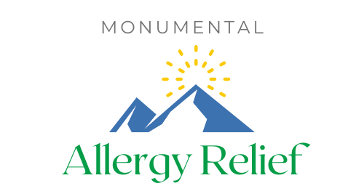
Waiver and Release / Informed Consent
I, __________________________________________ (the “undersigned”), hereby consent to treatment at
Monumental Allergy Relief located at 17180 Park Trail Drive, Monument, CO 80132
I understand that such procedures are non-invasive.
The clinic and all of its employees assume no responsibility for medical conditions requiring the attention of a medical doctor, or necessary adjustments to prescribed medications during or after the completion of treatments.
I understand the unpredictable nature of allergies and related symptoms and that the clinic cannot guarantee any results in the reduction of symptoms. The clinic cannot guarantee that new reactions will not develop in the future. While the treatment can address many symptoms associated with allergies and sensitivities, some cases do not respond to treatment.
I also understand that the only known risk factor with the treatment of symptoms associated with allergies and sensitivities, including immunotherapy, is the possibility of increased sensitivity. I assume all responsibility for unpredictable reactions which may lead to increased symptomatology. In this event, I agree to seek immediate medical attention.
I understand that the clinic does not treat cases of anaphylaxis and I agree to fully disclose all information regarding any life-threatening allergies, allergies resulting in anaphylaxis or any allergies that I have been prescribed an epi-pen.
___________ No, I do not have any life threatening allergies and do not carry an epi-pen
___________ Yes, I have the following allergies that may cause anaphylaxis
_________________________________________________________________________________________________
I agree to pay the clinic the standard fee for any and all treatments administered.
In witness thereof, the undersigned executed the Agreement as of (Date) _________________________

__________________________________________________ ______________________________________
Signature of Client Signature of Practitioner

___________________________________________________
Signature of Parent or Legal Guardian (if client is less than 18 years old)

